**CHAPTER 9**

**RESULT ANALYSIS**

A **true positive** test result is one that detects the condition when the condition is present.

A **true negative** test result is one that does not detect the condition when the condition is absent.

A **false positive** test result is one that detects the condition when the condition is absent.

A **false negative** test result is one that does not detect the condition when the condition is present. Let TP denote the number of true positives, TN the number of true negatives, FP the number of false positives, and FN the number of false negatives.

**Sensitivity** measures the ability of a test to detect the condition when the condition is present. Thus, Sensitivity = TP/(TP+FN).

**Specificity** measures the ability of a test to correctly exclude the condition (not detect the condition) when the condition is absent. Thus, Specificity = TN/(TN+FP).

**Predictive value positive** is the proportion of positives that correspond to the presence of the condition. Thus, Predictive value positive = TP/(TP+FP).

**Predictive value negative** is the proportion of negatives that correspond to the absence of the condition. Thus, Predictive value negative = TN/(TN+FN).

**Accuracy =** TP+TN/ (TP+TN+FP+FN).

***Table 9.1:*** *Correlation Table*

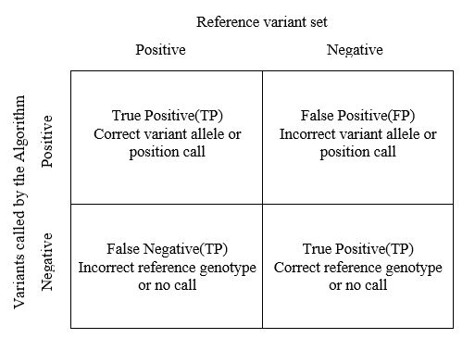

The training dataset consist of 100 fruit images. In non-real time the dataset consists of 10 fruits in 10 different angles with dimensions 100*100. The horizontal and vertical resolution is 96dpi. In real time the dataset consists of fruits in 10 different angles with dimensions 256*256. The horizontal and vertical resolution is 96dpi. The dataset is downloaded from [11] website.

***Table 9.2:*** *Result Analysis Table*

|  |  |  |  |  |  |  |
| --- | --- | --- | --- | --- | --- | --- |
| Fruit Name | No. of Testing Images | TP | TN | FP | FN | Result |
| Apple | 10 | 8 | 1 | 1 | 0 | 0.81 |
| Green Apple | 10 | 9 | 1 | 0 | 0 | 0.91 |
| Orange | 10 | 7 | 2 | 0 | 1 | 0.72 |
| Pomegranate | 10 | 8 | 2 | 0 | 0 | 0.82 |
| Strawberry | 10 | 7 | 1 | 2 | 0 | 0.71 |
| Tomato | 10 | 9 | 1 | 0 | 0 | 0.91 |
| Banana | 10 | 8 | 1 | 1 | 0 | 0.81 |
| Lemon | 10 | 7 | 2 | 1 | 0 | 0.72 |
| Mango | 10 | 9 | 1 | 0 | 0 | 0.91 |
| Dates | 10 | 8 | 1 | 0 | 1 | 0.81 |

**Average overall accuracy**=0.8173=81.73%